Updated Links
Fragments Microservice:
https://github.com/MansoorAZafar/fragments
Docker-file on GitHub:
https://github.com/MansoorAZafar/fragments/blob/main/Dockerfile
The difference in GitHub
https://github.com/MansoorAZafar/fragments/commit/da2ecef60c87d651e5295eba99d14a757e7d3228
(All optimizations are mentioned at the ending part where I explain them)
Docker Hub Fragments Repository:
https://hub.docker.com/r/mansoorazafars/fragments/tags
All Docker Tags:
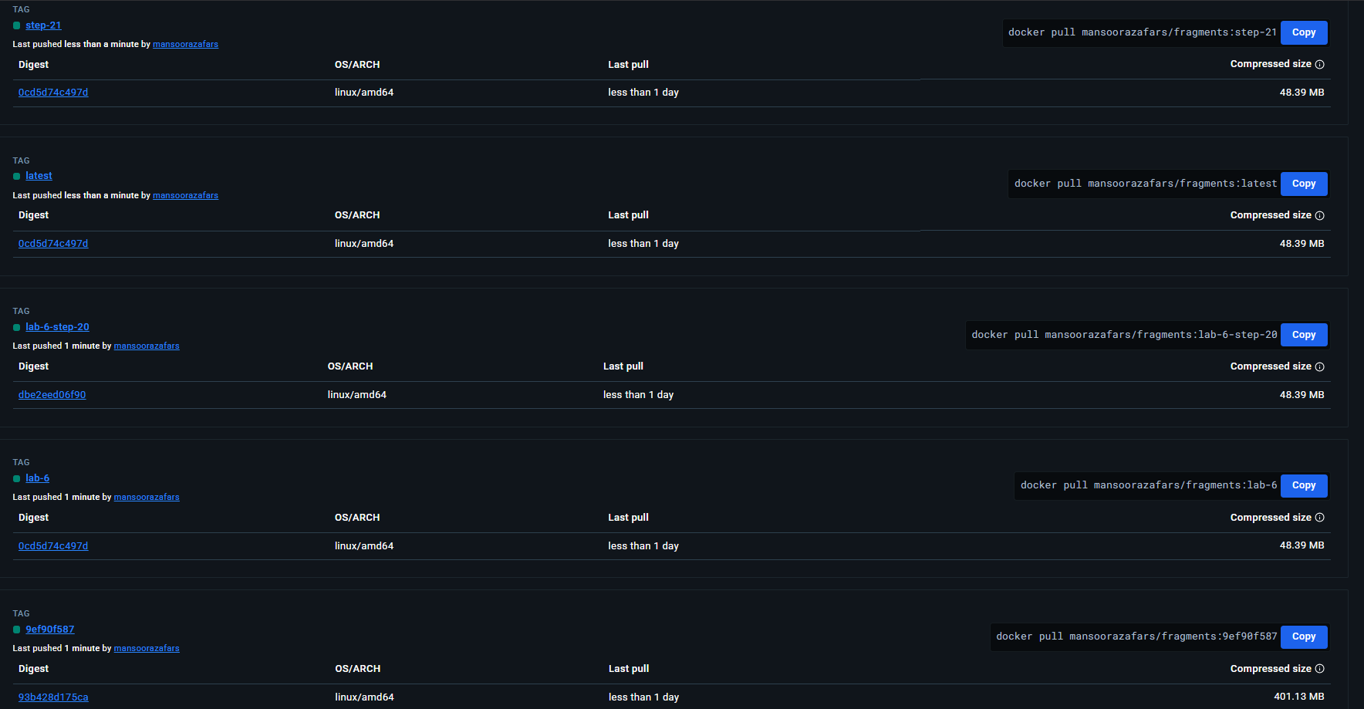
EC2 Instance Running fragments Docker Hub image
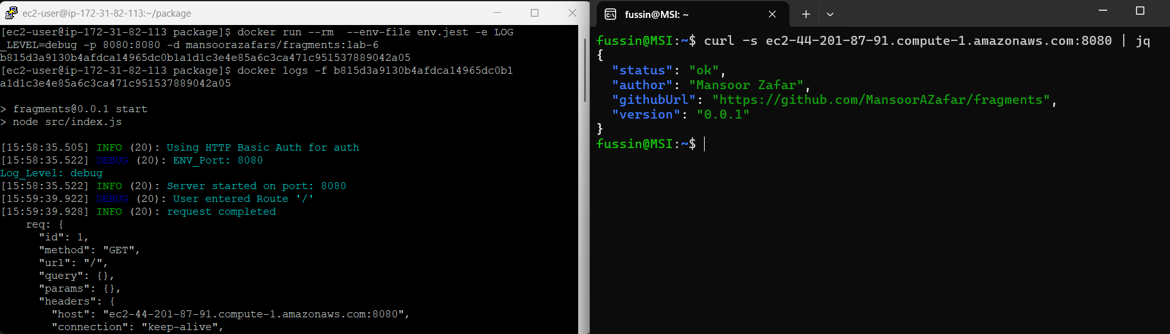

Explanation of Optimizations
Reducing the Size.
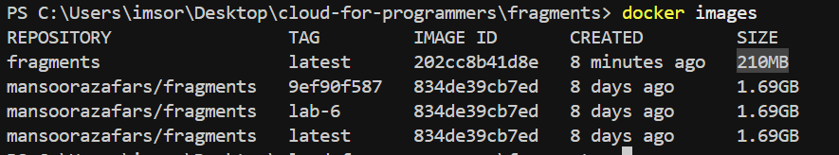
Note, the fragment image is the optimized size, and the others are the size of the pre-optimized ones. For reducing the size, I utilized the two optimization techniques of using official images, explicit image versions and only getting production dependencies. Firstly, I used the official alpine image with the specific version for my node which can be seen below:
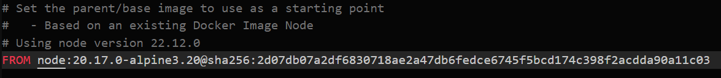
I used the exact version of alpine for my respective node version with the exact sha version. It can be found here: https://hub.docker.com/layers/library/node/20.17.0-alpine/images/sha256-7cf59943220395db9051c2ff6a2b7c30b34632ff81e7add22e07c0cd787f15bb. Then, as I said, I used ENV NODE_ENV=production and RUN npm ci --only=production to ensure that only the dependencies needed for production were installed and those for development were left out. This also relates to the Development vs Production optimization, as I left out all the development dependencies and ensured only production was left.

Design In Layers:
My Docker-file, it broken down into 6 stages, this is how I designed in layers, they are separated by how much they may change. At the 0th layer/stage we have the installation of Alpine and Node. I set this as the 0th stage as it should not change unless absolutely necessary.
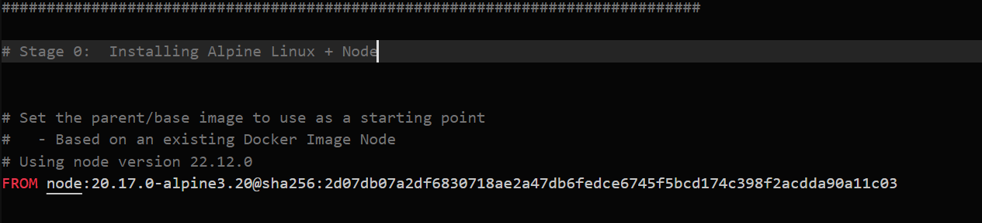
Then, at the 1st stage we have setting up environment variables and the working directory. These may have more environment variables added but generally not.
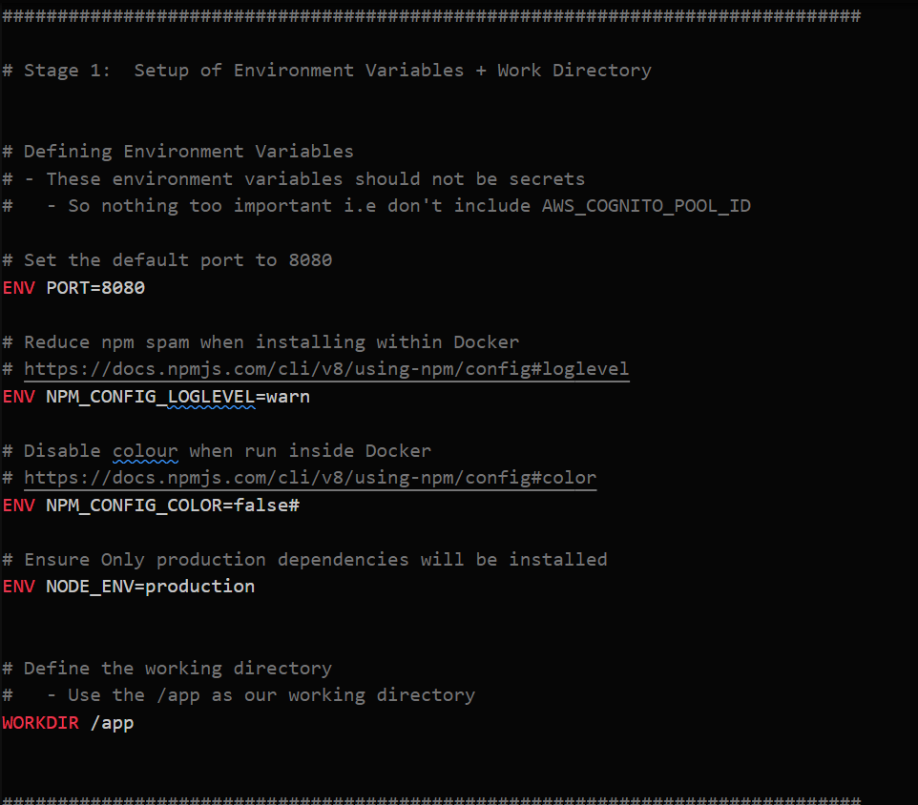
Then, comes the 2nd stage where I install the dependencies. As you can explicitly declare the pathing of the files, I decided that under certain circumstances, a user would probably need to change the file paths where you install the dependencies more than the changing the work directory or not-so-secret environment variables.
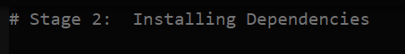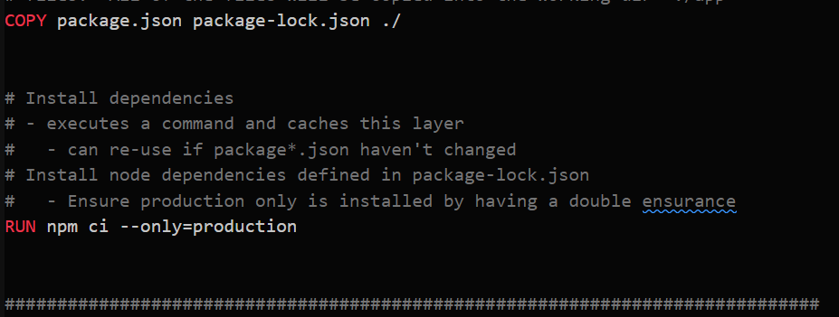
After, for the 3rd stage, here you copy the files to the image. I put these in the 3rd stage as in the lab, we had to add an additional copy to make the env.jest work. So, adding files here can happen more often than the ones above.
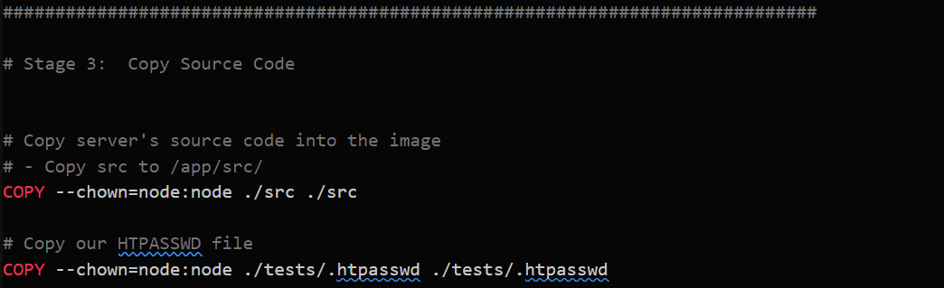
Then, you have the 4th stage which is just for metadata like the labels, these can be changed often as more data is needed or changed.
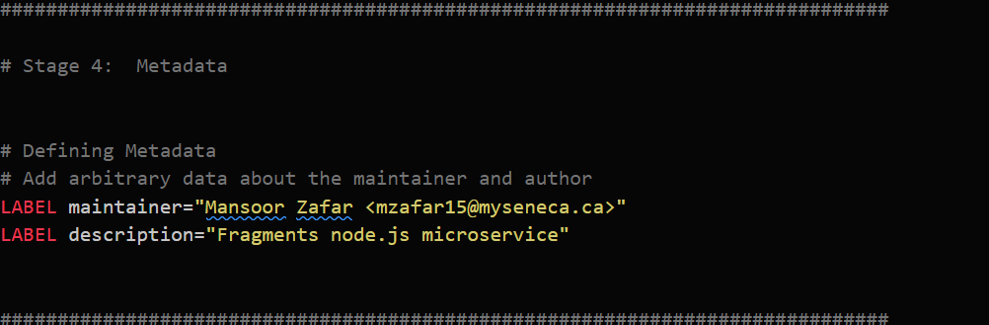
Finally, the 5th layer, this one handles the ‘building’ of the microservice. This exposes the port the microservice will exist on, switches the user, setups the health check and provides the starting command.
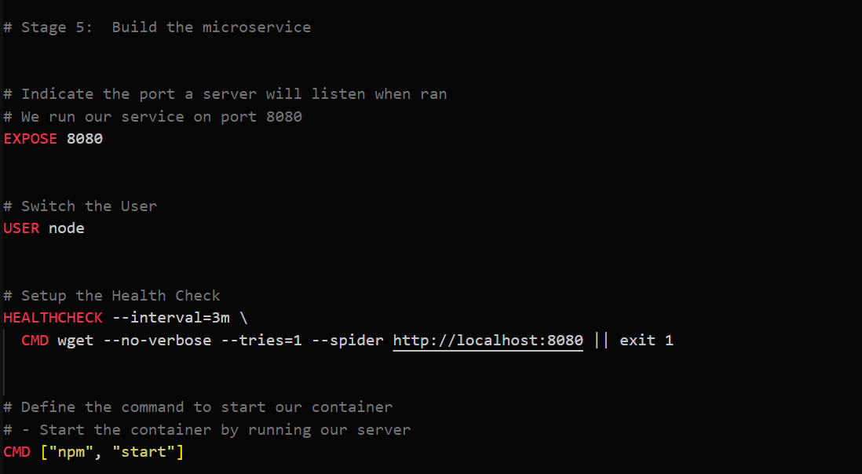
As, you may change ports or even need to add additional arguments for the starting command or change the frequency of the health check, this is the one that would change most and needs to be at the end as it starts the application given all other steps are done.

Health Check
As I glossed over it earlier, I also added a health-check. This health check uses wget as to avoid needing to download curl and not need to worry about having another dependency and uses –spider to avoid downloading the actual file. It has a 3-minute interval and exits if it failed.
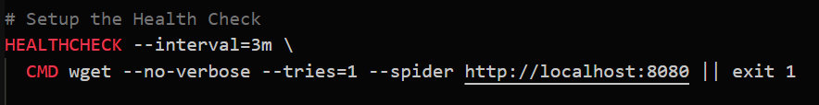

Better Init Process
For this, it’s more of just I added the –init flag when running the docker container. However, I will say, I chose not to change the starting CMD from “npm start” to “node src/index.js” because, with our package.json, npm start is just basically an alias for writing node src/index.js, it doesn’t start any extra process as our package.json has it defined as pretty much just an alias. So it’s the same as if we wrote node src/index.js but with our package.json we just made essentially an alias.
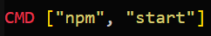
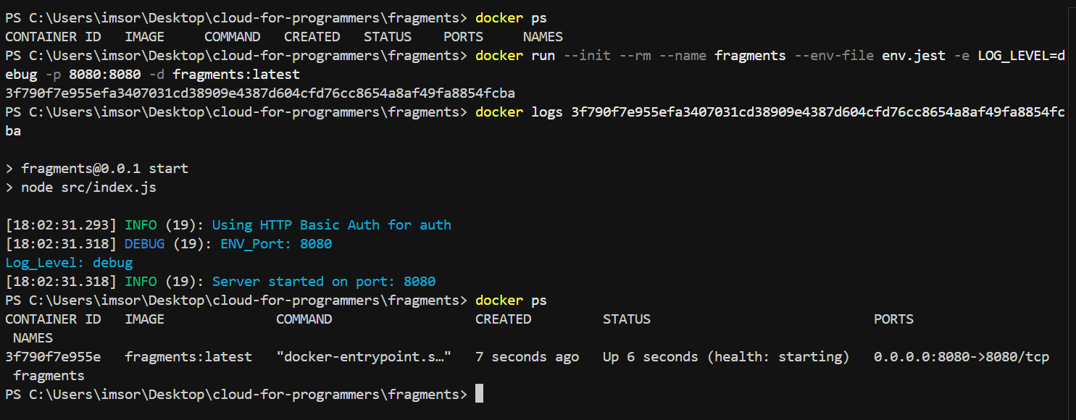

Least Privileged User
For this, I simply changed the user from root to the node. This was done as to prevent the user from any root access and potential leaking of information. I changed the ownership to node rather than root.
